**ILS Z534: Search**

**Assignment-3: Query-Centric PageRank**

**Author: Sanjana Pukalay (spukalay)**

**Output and Findings**

1. **Output of AuthorRank:**

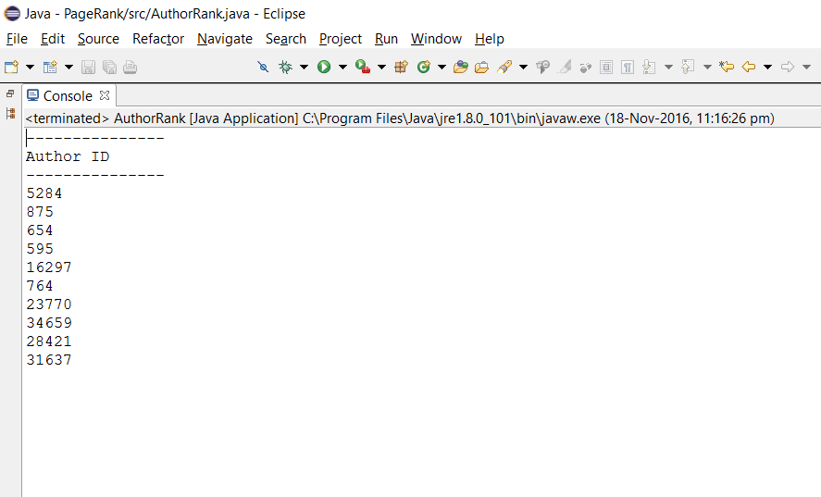

1. **Output of AuthorRankwithQuery:**

